After doing so, identify what type of research it is (e.g., qualitative, quantitative or mixed). Pay attention to the problem and objectives, the nature of observation, the nature of data, the data analysis and presentation of the results and findings. Report your analysis to the rest of the class by posting a five-minute-video analysis to our class stream.

Qualitative research focuses on generating meaning and understanding through rich description.

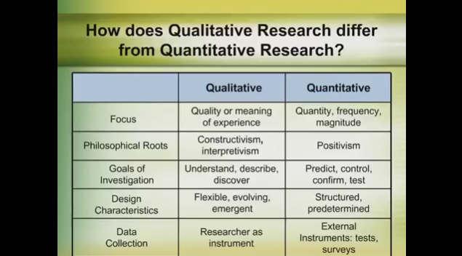

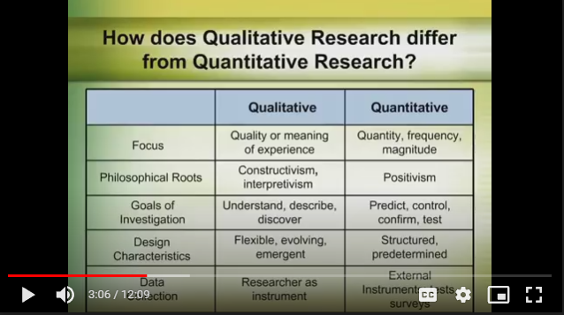

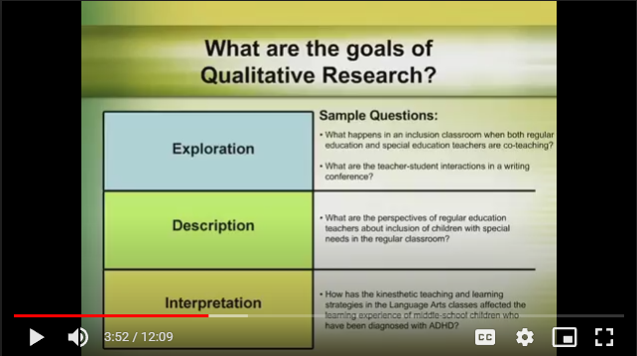

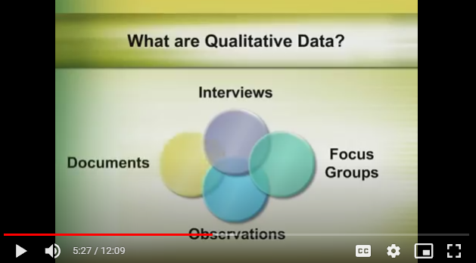

Qualitative data are typically obtained from sources such as interviews, focus groups, observations of real-life settings, and existing documents.

Netspeak features in Facebook communication of Malaysian University students

Data Analysis

The framework for analysis of netspeak features was adapted from an existing framework, as seen in table 1, which included word compound, word creation, abbreviation, capitalization, spelling, and punctuation. During the process, features of netspeak not in the original framework were found and these were added to the framework: dropping of vowel, homophone, negation, code-switching, using of “2” for repeated words, and spacing. The framework pointed out that word compound and word creation fall under the neologism category but it did not deal with homophone and negation, thus these two features were added to the framework. In addition, the framework's spelling domain was too generic that’s why the researchers sub-divided it into addition/replacement of letters, dropping of vowel, and repetition. The use of the numeral 2 for repeated words was widely used in Malay for note-taking as many of the plural forms of Malay words consist of using a hyphen in between the same word (e.g. “buku-buku”). Spacing is an important feature of digital texts as users are getting used to not using the space bar on the keyboard due to the advancement of predictive keyboard software on mobile phones.

Results and Discussion

According to the study, the total number of netspeak features identified is 917, and the highest three are dropping of vowel (23.12%), punctuation adaptation (19.41%), and slang (16.34%).  These three features have frequencies between 150 and 212 each but the frequency of other  netspeak features are below 75.

1. Word formation

Word formation occurrences account for 42.86% of netspeak features in the Facebook status posts of the 24 students, and among the three types of word formation, word compression is the most frequent (8.07%), followed by homophone  (5.67%) and negation (1.85%). Word compression involves altering and shortening words like “cos”  for “because”, “smth” for “something”, “tmr” for “tomorrow”, and so on. The data analysis revealed that the students also took two or more words and combined them into one word.

1. Use of 2 for repeated words

The numeral 2 is used to show repetition of words 13 times (1.42% of 917 netspeak features) for  Malay words. For example, “betul2” for “betul-betul”, “besar2” for “besar-besar”, etc. The repetition is either for emphasis or to show plural form.

1. Abbreviation

Surprisingly, not many abbreviations are used except one particular “lol” for “laughing out loud”,  with variations like “lols”, “lolll”. Only 0.98% of 917 netspeak features identified were abbreviations.  Popular abbreviations like “omg” for “oh my god”, “wtf” for “what the fuck” are not present. These  abbreviations are exclusive features of social media which are not found in other forms of spoken  and written communication.

1. Code switching

refers to the “juxtaposition within the same speech exchange of passages of  speech belonging to two different grammatical systems or subsystems”. As we can see in the example here, Malays also code-switch especially in informal settings like communicating on Facebook. Though, Code-switching adds emotion to a sentence but it is not a common feature of netspeak (5.56% of 917  netspeak features).

1. Slang

Slang is the third common feature of netspeak, accounting for 16.34% of 917 occurrences in the  Facebook status posts analysed. Common examples are “haha”, “eh”, “la”, “bah”, “mah”. Slangs used  in Malaysia differ across cultures. The analysis showed  that slang is a common feature of netspeak and the meaning of slangs depends on the context,  particularly the ethnicity of users and the language used.

Conclusion:

The analysis of students’ Facebook conversations for netspeak features showed that social media  has changed the way people communicate. With social media communication being concise and  happening in real-time, it shares similarities with spoken language. Four netspeak features resemble  features of speech, namely, homophone, addition/replacement of letters, code switching, and slang.  The netspeak features that have features of written communication are dropping of vowel, negation,